Patient Participation Group (PPG) Meeting Minutes
Practice: The Corner Surgery
Date: 16 September 2026
Time: 1:00pm
Venue: The Corner Surgery
Chair: Ann Doring
Minutes Prepared By: Elaine Cawsey (from meeting transcript)
Present
- Dr Smith
- Elaine Cawsey
- Ann Doring
- Mary Porter
- Vera McGibbon
Apologies
- Howard Poole
- Jenny Poole
- Ken Owen
- Anne Cameron (also advised she is stepping down from the PPG)
- Sheila Whitebrook
- Katie Caudwell

1. Welcome and Apologies
Dr Smith welcomed attendees and noted several apologies had been received. The group recorded its thanks to Anne Cameron for her contribution to the PPG and acknowledged her resignation due to meetings regularly falling on her working day.

2. Approval of Previous Minutes
The minutes of the previous meeting were reviewed.
Matters Arising
- Clarification was provided that ICB stands for Integrated Care Board, which replaced the Clinical Commissioning Group (CCG).
- The previously vacant Vice Chair position was discussed.
Resolution
- Dr Smith was nominated and agreed to act as Vice Chair of the PPG.
- Agreed unanimously by those present.

3. PPG Membership and Recruitment
The group discussed the continuing decline in PPG membership and the need to recruit new members.
Agreed Actions
- A recruitment campaign will be undertaken during the upcoming flu clinics.
- Promotional posters will be displayed.
- Interested patients will be invited to leave their contact details.
- Ann volunteered to assist with speaking to patients and promoting the PPG during clinic sessions and Mary would also join to help.
The group recognised the importance of increasing membership while maintaining an active and engaged core group.

4. Use of Technology for Minutes
Elaine advised that Microsoft Teams transcription had been used to record and transcribe the meeting.
The aim is to:
- Improve efficiency in producing minutes.
- Reduce manual note-taking.
- Explore future use of AI-assisted minute production.

5. Practice Update
Multifunction Room Project
Dr Smith provided an update on plans to divide the multifunction room into two separate clinical rooms.
Update
- Funding is secured.
- Legal agreements have been signed by the practice.
- Awaiting final landlord approval.
- Work is expected to begin towards the end of September.
- Construction is expected to take approximately three to four weeks.
Impact
- Temporary disruption during building works.
- The room will be unavailable during construction.
- Noisy works are planned for weekends wherever possible.

6. Car Parking Update
The group discussed ongoing concerns regarding parking restrictions and fines issued to patients.
Current Position
- Additional signage has been installed.
- Staff are making efforts to support patients whose appointments run beyond the parking allowance.
- No further concessions have been secured from the parking operator.
The issue remains outside the practice's direct control.

7. Patient Information and Transparency
The practice has produced a patient information poster displaying key practice activity data, including:
- Appointment numbers
- Prescription workload
- Patient registrations
- DNA (Did Not Attend) figures
Suggestions
- Display information prominently near self-check-in facilities.
- Investigate displaying key information on waiting room television screens.
Action
- Dr Smith to investigate whether practice-specific information can be displayed on the waiting room screens.

8. Did Not Attend (DNA) Review (Appendix 1)
Following a request from the previous meeting, the practice conducted a survey of patients who had missed appointments.
Findings
- 53 DNAs recorded during August.
- 49 patients were eligible to receive a text survey.
- 46 surveys were sent.
- 16 responses received.
Reasons Given
- Unable to attend: 10
- Forgot appointment: 6
- No longer required appointment: 0
Discussion
Members noted:
- DNA appointments represent a significant loss of clinical capacity.
- Reminder systems appear to be helping reduce unnecessary appointments.
- Further publicising the impact of DNAs may encourage attendance and cancellation of unwanted appointments.
Action
- DNA information to continue being included in patient awareness materials.

9. GP Patient Survey Results (Appendix 2)
Dr Smith presented the latest GP Patient Survey results.
Key Results
- Overall patient satisfaction: 93%
- Results significantly exceeded Cheshire and Merseyside averages.
- Improvements noted in:
  - Telephone access
  - Website access
  - Overall patient experience
Discussion
Members welcomed the positive results and recognised:
- Improvements to the telephone callback system.
- Better visibility of online contact forms.
- Consistently positive feedback regarding reception staff.
Visit: GP Patient Survey for further details.

10. Vaccination Consent Process Changes
Changes to vaccination consent requirements were explained.
Key Points
- New guidance requires formal consent arrangements for certain vaccinations.
- First-time recipients of vaccines such as shingles, pneumonia and RSV or first-time influenza require enhanced consent procedures.
- Educational videos have been created and added to the practice website to streamline the process that patients must watch before attending for a vaccine for the first time.
Flu Clinics
- Sunday flu clinic morning sessions are fully booked.
- Afternoon sessions are approximately half full.
- Additional weekday clinics are also available.
The practice believes new processes will allow flu clinics to continue operating effectively.

11. Staffing Update
Administrative Team
- New reception staff:
  - Rose
  - Georgina
- Amy has left the practice.
- Recruitment is underway for a Reception Supervisor position.

Clinical Team
- Dr Ryan has joined on a regular Wednesday session.
- Dr Cosgrove continues on Tuesdays.
- Dr Scholtz is providing locum support.
- Dr Wray continues on Fridays.
- Current Resident Doctors are:
  - Dr Hisham Sharaf
  - Dr Peter Whittle
Members discussed continuity of care and were reassured regarding communication between clinicians through regular meetings and clinical collaboration.

12. Pharmacy and Prescribing Services
The practice has partnered with Ashburton, a pharmacy support provider.
Benefits
- Successful cover provided during pharmacist leave.
- Additional prescribing support from September to March.
- Increased capacity for medication reviews.
- Expected release of GP appointments for other patient needs.
This work is being supported through winter pressures funding.

13. Complaints and Patient Feedback
Dr Smith reported that:
- The volume of complaints has increased compared with previous years.
- Many complaints appear to be generated using AI tools.
- All complaints continue to be reviewed and analysed for common themes and learning opportunities.
The practice undertakes quarterly reviews of:
- Complaints
- Significant events
- Emerging trends

14. Wider NHS Developments
A brief update was provided regarding neighbourhood health initiatives and pilot work taking place across Sefton.
No significant developments were available to report at present due to delays and uncertainty surrounding future direction.

15. Any Other Business
PPG Visibility
The group discussed improving awareness of the PPG through:
- Posters
- Website promotion
- Possible use of waiting room television screens
- Recruitment during flu clinics
Members agreed that raising the profile of the PPG should remain a priority.

16. Date of Next Meeting
Wednesday 20 January 2027
Time: 1:00pm
Venue: The Corner Surgery

Action Log
Action | Responsible | Timescale
Recruit new PPG members during flu clinics | Ann, Mary & Practice Team | October 2026
Display PPG recruitment materials during flu clinics | Practice Team | October 2026
Continue quarterly patient information posters | Practice Team | Ongoing
Investigate use of waiting room TV screens for PPG/practice information | Dr Smith | Before next meeting
Continue monitoring and publicising DNA figures | Practice Team | Ongoing
Include GP Patient Survey results in meeting records | Elaine/Practice Team | Completed

Meeting closed: Approximately 2:15pm.

Appendix 1
Did Not Attend Questionnaire
Search for DNAs for August 2026 found a total of 53.
49 patients could be contacted by text message, and a questionnaire was sent on 07/09/26.
3 patients opted out of completing the questionnaire.
The text message was delivered to 46 patients.
The link expired for 7 patients.
The questionnaire asked patients is they could provide the surgery with some feedback regarding their recent DNA and asked them to provide us with the reason for DNA with a choice of 3 options:
- Forgot
- Unable to Attend
- Appointment no longer needed
We received 16 completed questionnaires.
We can see from the messaging platform that 9 questionnaires were partially completed but not sent.
21 questionnaires were not started.
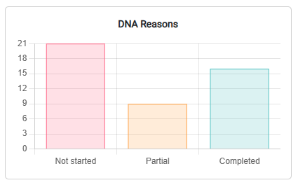
Of those completed, the following answers were recorded:
- Forgot: 6
- Unable to attend: 10
- No longer needed the appointment: 0
One patient telephoned the surgery to say they were unaware of the appointment.

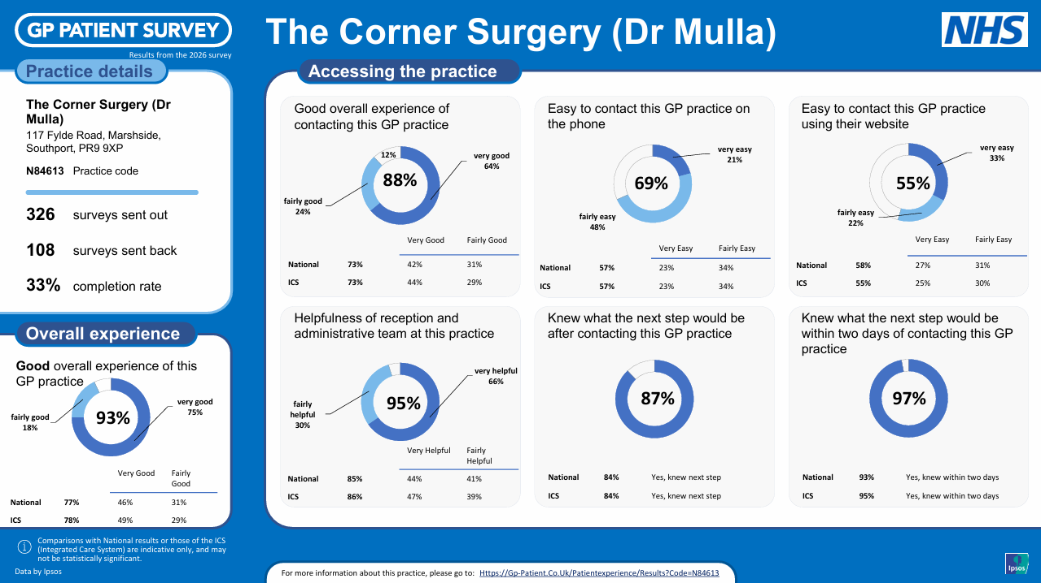
Appendix 2
